Teaching Outside the Classroom
by Lily Claiborne, John Morrell, Joe Bandy and Derek Bruff
Teaching and learning can become inherently spontaneous and student-centered when moved from the confines of the classroom into the world at large. From the collaborative learning atmosphere that results from the unique relationships developed outside the classroom, to the deep learning that occurs when students must put into practice “in the real world” what they have theorized about from behind a desk, field experiences are unmatched in their learning potential. Field experiences early in a student’s career can be formative and can inspire students to continue in a field.
Learning experiences outside the classroom are inherently interdisciplinary. When we go out into the world, we encounter it as a whole and are forced to engage multiple modalities, no matter which pair of disciplinary “lenses” we intended to wear. Therefore, scientists and humanists alike do well to consider the ways in which other disciplines might enrich their own disciplinary approach to their field.
There are many ways to make learning extend outside the classroom:
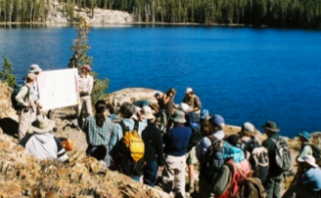

Field Trips
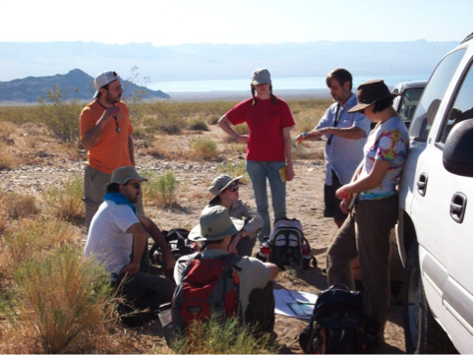The phrase “field trip” may bring to mind long bus rides, sack lunches and museum tours, but field trips can take a variety of forms that meet a variety of needs and can enhance deep, active learning. Along with the engagement with concepts that is required by these experiences, the student bonding that occurs on field trips enhances the learning experience and creates a learning community as students continue onward in a discipline. Teaching in the field also gives instructors the opportunity to get to know their students in greater depth in terms of how the students see the world differently than the instructor. This insight into student world-views can help the instructor to better communicate the concepts of the course.

Tips and Techniques:
These tips were provided by VU faculty experienced in taking students on field trips.
- Set up the field trip as a research project that includes data collection.
- Conduct a theoretical examination of the issue in class long before going into the field. Students should have a sense of what the field trip is going to be about before they go.
- At least two weeks before heading into the field, develop the rudiments of basic hypotheses. At this point the instructor should give details about the field site so that students know what to expect.
- In the field, focus on the things that you’ve agreed to focus on and let the other stuff be icing on the cake.
- Take a backpack full of extra warm/dry clothes and snickers to pass out to students as the need arises.
- If for a large class, prepare TAs well to manage smaller groups of the class.
- Prepare students for practicalities including appropriate attire, expectations for physical exertion, anticipated rest stops, supplies and materials they should bring

Issues to Consider/Prepare For:
- Transportation
- Creating a sampling method suitable for students with minimal previous experience
- Weather
- Coordination with external personnel
- Effective use of TAs as team leaders (management of group dynamics)
- Student allergies and fears; safety
- The Out-of-Classroom Experience by Dave Douglass: A comprehensive article on things to consider when “dreaming-up, organizing, planning and leading field trips and other learning activities that will take place outside of the traditional classroom setting”

