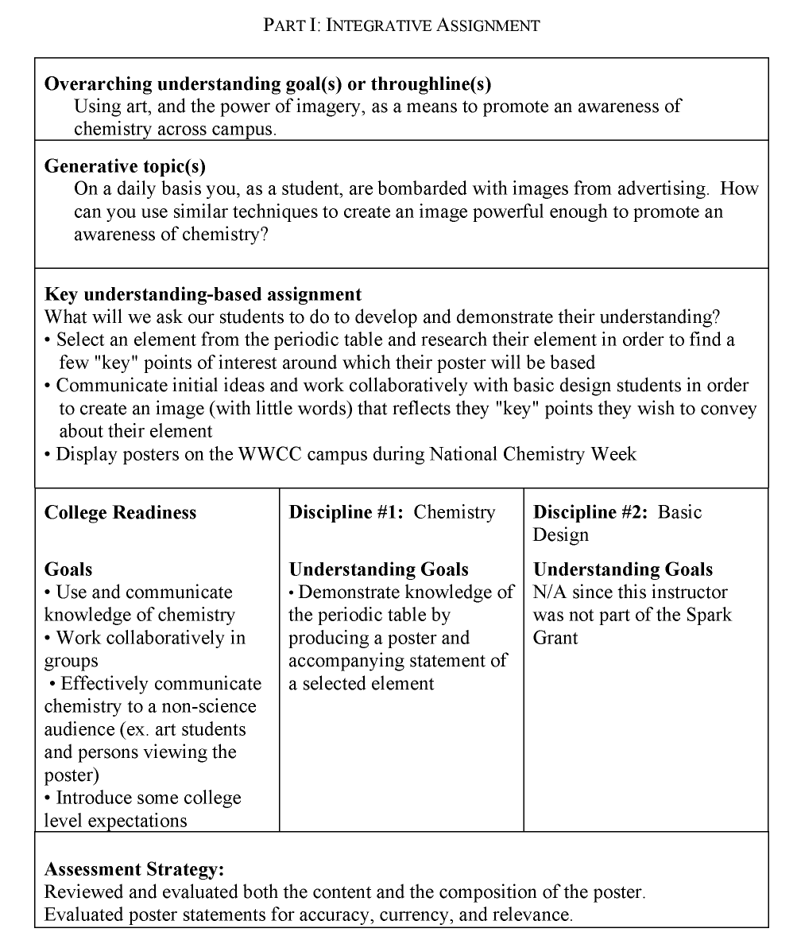

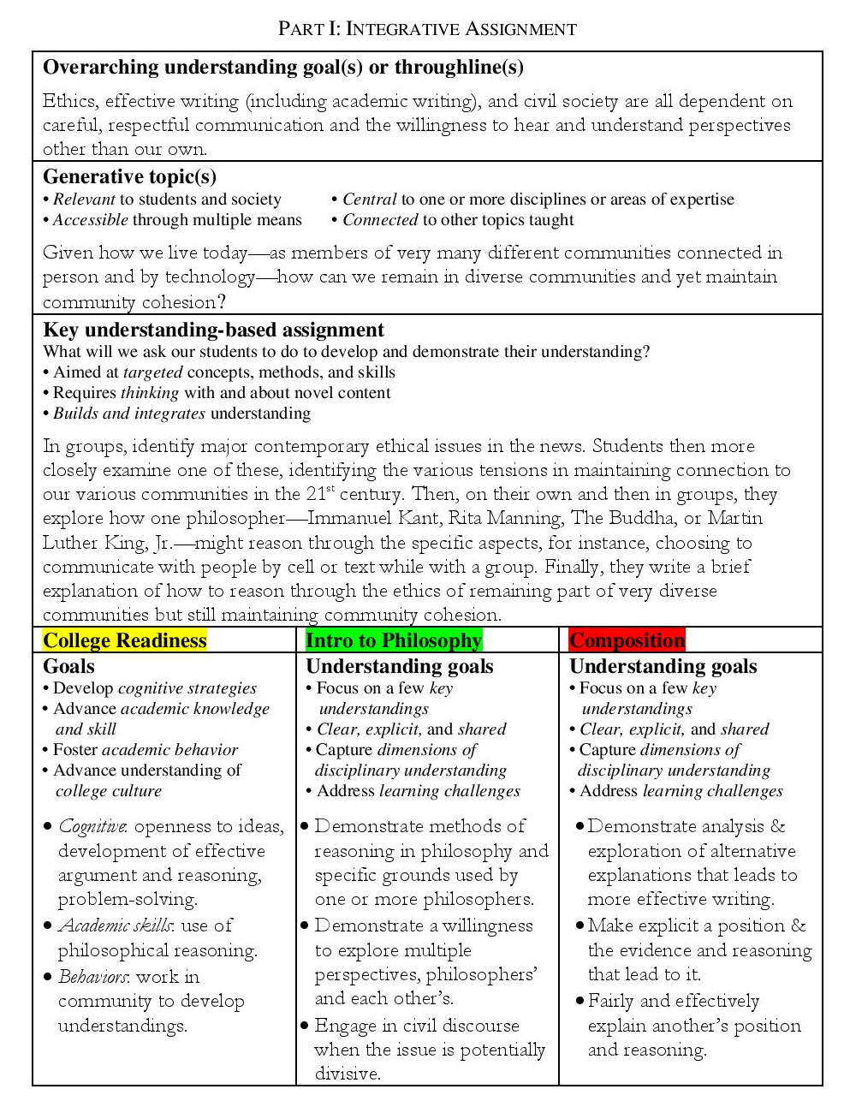

Integrative Assignment Plan
Overarching goal(s) for the integrative assignment (what we want our students to learn)

Generative question (a question to get our students interested and invested in the topic)

Main goal-based assignment (what we will ask our students to do to develop and demonstrate their understanding of concepts expressed in our goal)

Freshman Forum | Course 1 | Course 2

Assessment (how we will assess students’ learning of the stated concept(s) expressed in our goal)

