How to Use Templates in Brightspace
Step 1: Make sure you are in your course. Now select Course Admin in the Navbar.
Step 2: When in the Course Administration page, you will click on Manage Files.
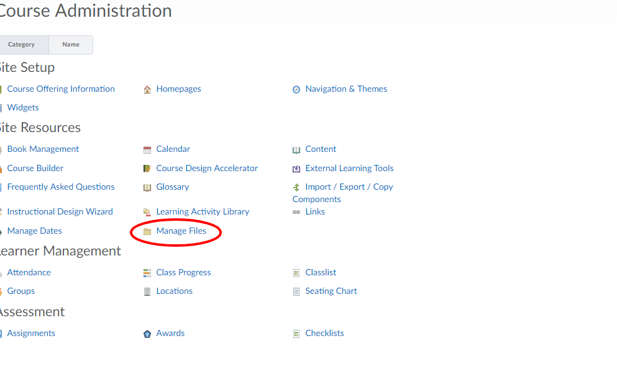
Step 3: Now that you are in Manage Files you will click Upload.
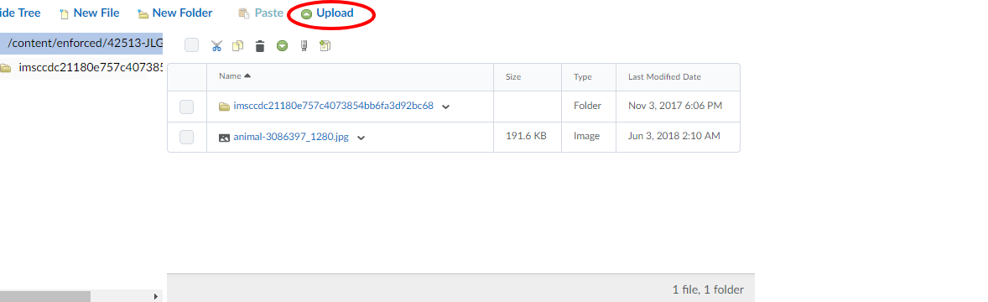

Step 4: You will now either click Upload and locate your file, or Drag and Drop the file in the dotted box.
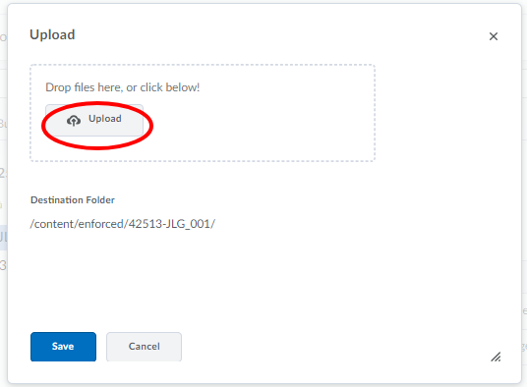
Step 5: Once the file has been uploaded, you will now click Save.
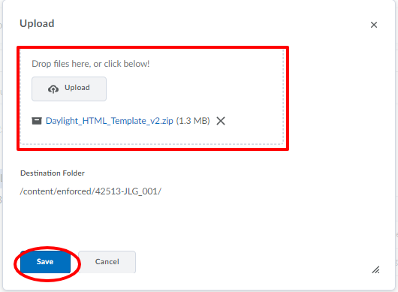

Step 6: Once the file is uploaded you need to locate the file in Manage Files. Once located click the Down Arrow next to the file, now click Unzip.
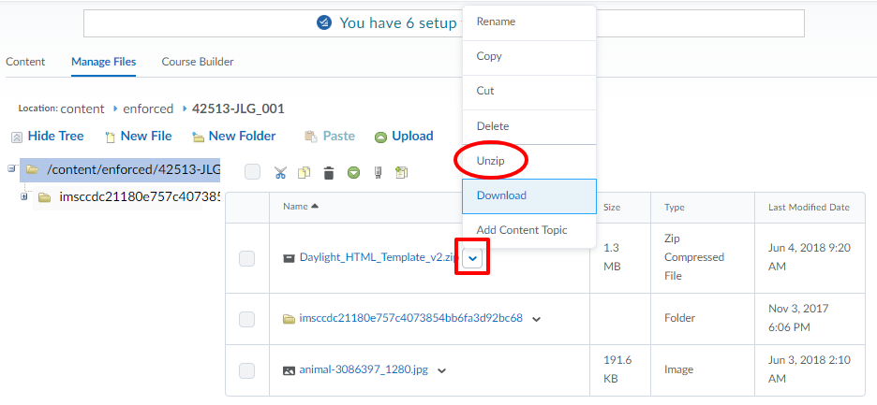
Step 7: You will now click OK.
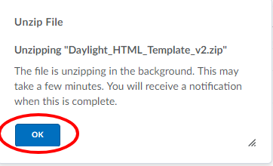
Step 8: Once you have unzipped the file, you will now click on Content.
Step 9: Once in Content area you will now click on Settings.
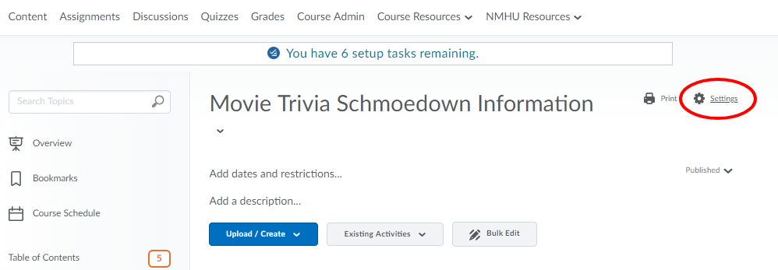
Step 10: Once in the Content Setting menu you will place a check on Enable HTML Templates.
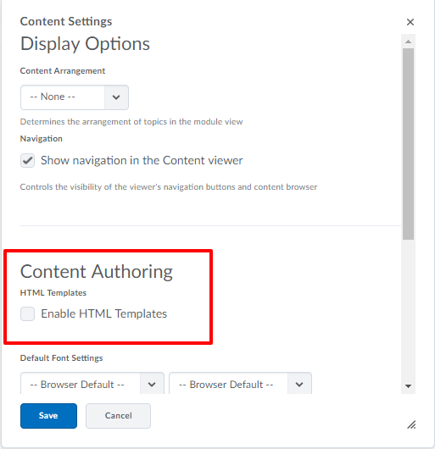

Step 11: After checking the box you will now click on Change Path.
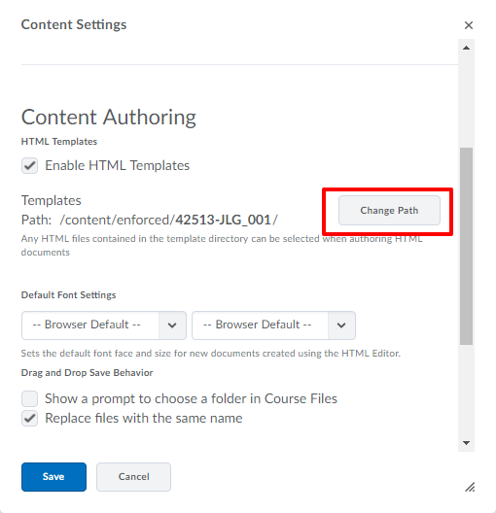
Step 12: Now you will locate and click on the Daylight_HTML_Template. Once you have done that you will not click Select Path.
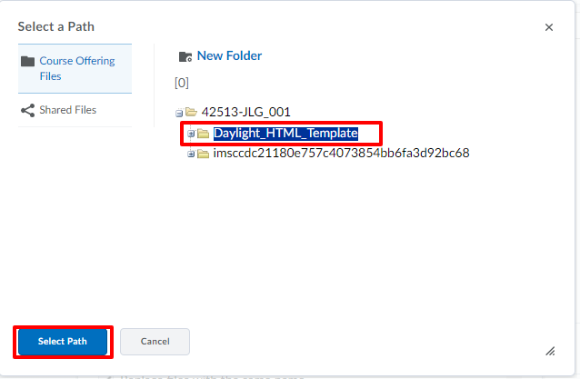
Step 13: Once the path has been selected you will now click Save.
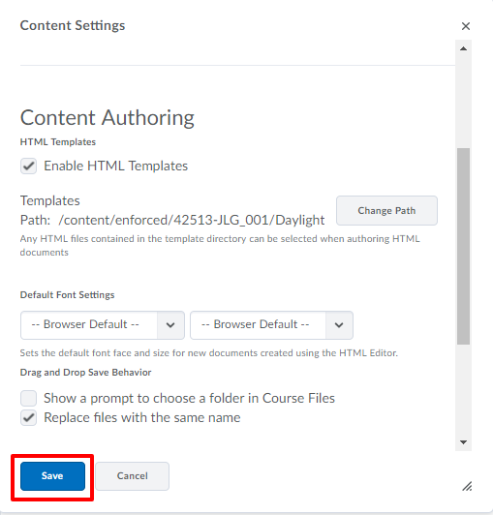

Step 14: Once you are back in the Content area, you will now click on Upload/Create and the option Create a File.
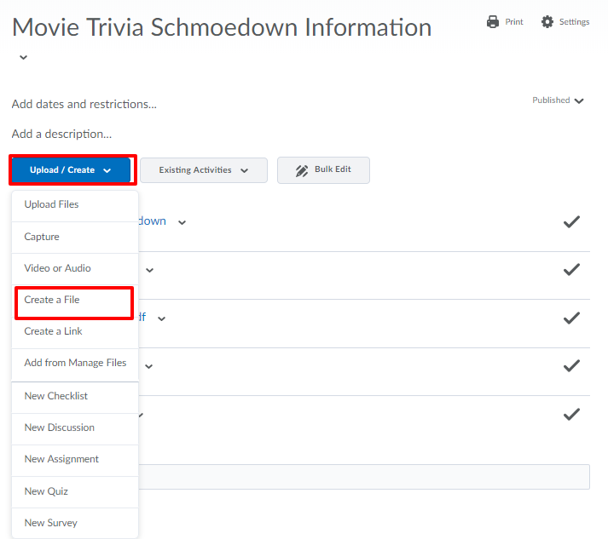

Step 15: Once on the HTML file creation page you will now click on Select a Document Template. This will give you the options for the HTML pages that are premade.
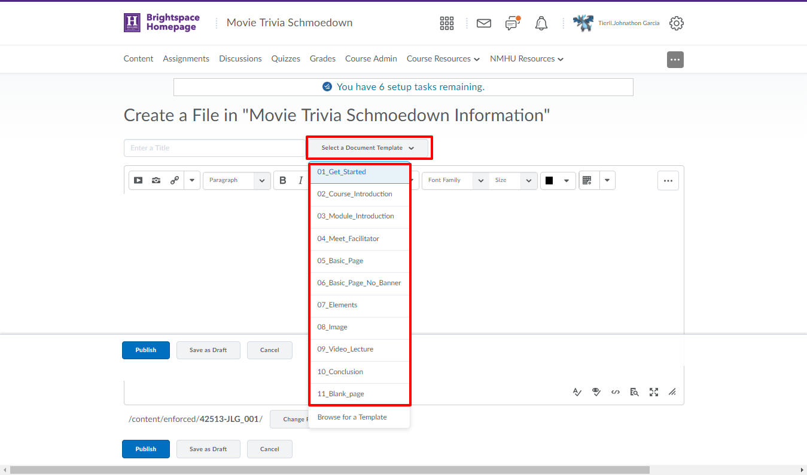
Step 16: Once you have selected the template you can now edit the template with your information.
