Desire2Learn Rubrics
Overview: With the Rubrics tools, instructors can quickly grade student work using either a holistic grading system or by rating the work against one or more criteria. When instructors do not use rubrics, students receive feedback as a single numeric score with or without typed feedback. Rubrics make it possible to provide detailed feedback based on the level of achievement of a particular criterion without typing an individual set of feedback for each student.

The Two Types of Rubrics

Analytic Rubrics | Most rubrics are analytic. An analytic rubric breaks performance into multiple criteria. You assess each criterion separately, resulting in an overall assessment score.
Holistic Rubrics | Holistic rubrics do not break performance into separate criteria. Performance is assessed holistically, so that you consider several different criteria, but make only one overall assessment.
Holistic Example
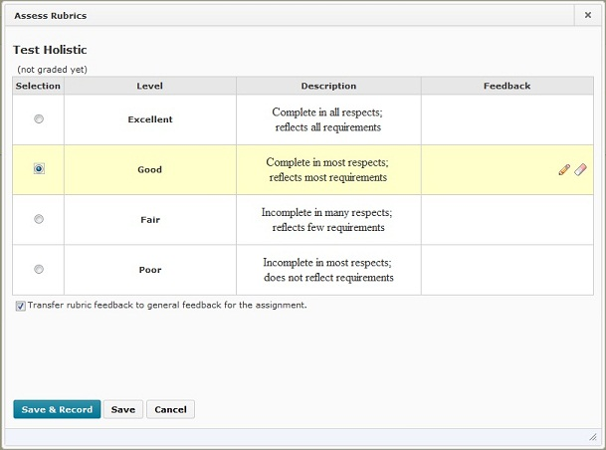

Analytic Example
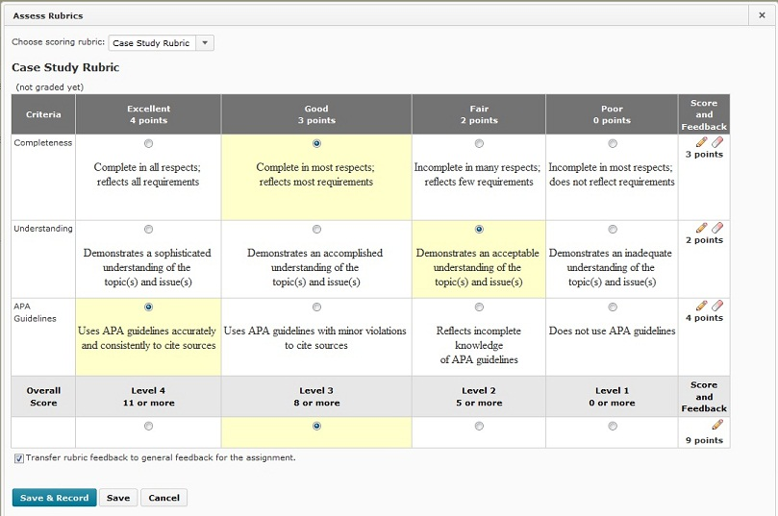

Accessing Rubrics Tool
The Rubrics tool can be accessed by clicking on the “Resources” link located on your course homepage NavBar or by clicking Create Rubric in New Window during the properties set up of an activity such as a Quiz, Dropbox Folder, Discussion, or Grade Item.
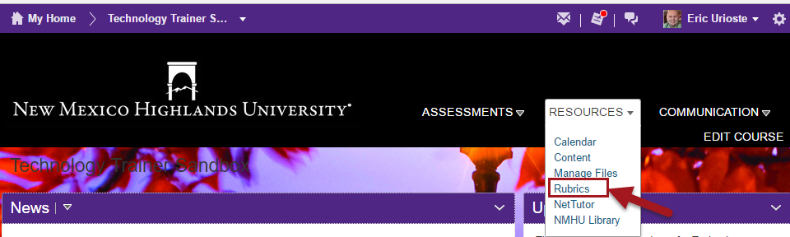

Creating Rubrics
Whenever you are creating or editing activities that can be assessed such as dropbox assignments, quizzes, or discussions you can create a rubric.
NOTE: A rubric cannot be edited once it has been associated with an activity.
Holistic rubrics allow you to assess participants' overall achievement on an activity using a single criterion.

Initial Setup (Analytic Rubric)
Analytic rubrics allow you to assess achievement on an activity based on more than one criterion in a single rubric. With analytic rubrics, levels of achievement are displayed in columns and your assessment criteria are displayed in rows.
- Locate the “Resources” section of Desire2Learn which can be found on your course homepage NavBar then choose the “Rubrics” option.
-or-
Click the “Create Rubric in New Window” during the properties set up of an activity such as a Quiz, Dropbox Folder, or a Discussion. (Below is an example of the properties page of a dropbox folder where a Rubric can be created)
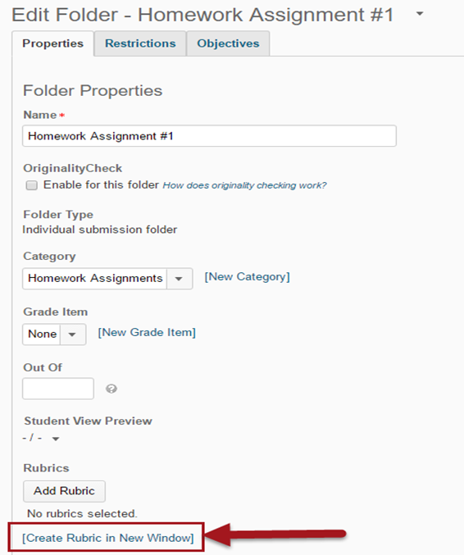

- Click the “New Rubric” button.
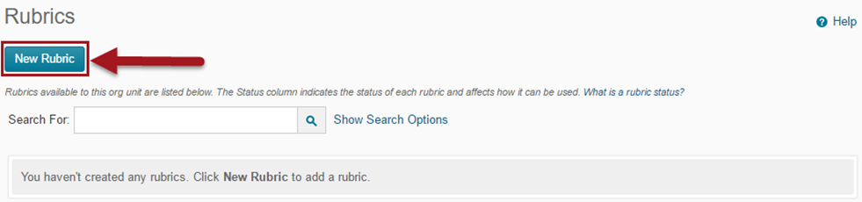

- Rubrics Properties Page.
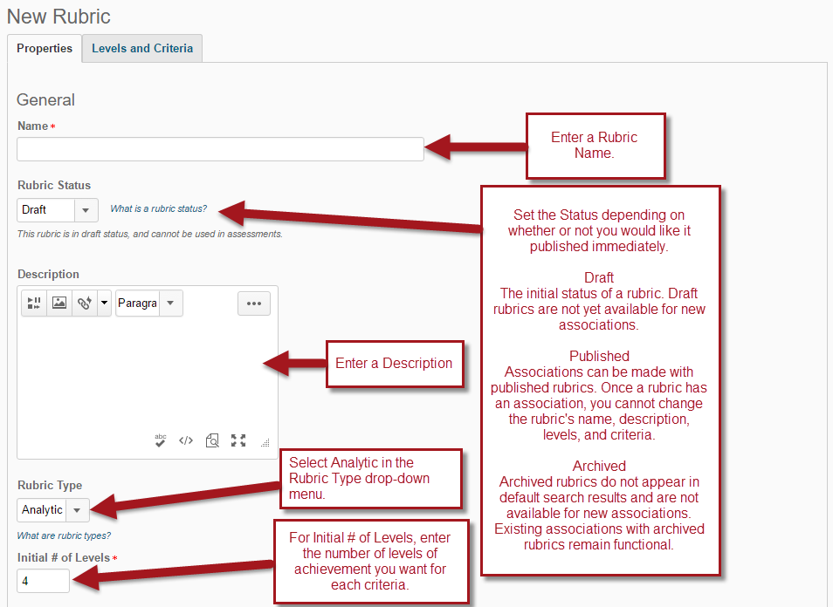

Rubrics Properties Page continued.
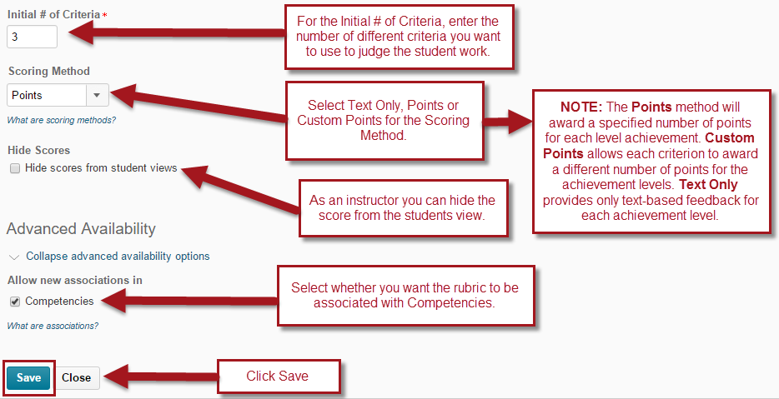
Note: You can associate a rubric with a tool such as Competencies or e-Portfolio as a means of assessing items created in those tools. When you create an association for a rubric, you cannot edit or delete the rubric. To make changes after associating it with a tool, you should change the rubric’s status to “Archived” then copy the rubric and make your changes to the new copy.
- Defining the achievement levels and criteria: Click the Levels and Criteria tab on the New Rubric or Edit Levels and Criteria from the Rubric homepage.
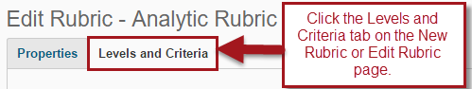
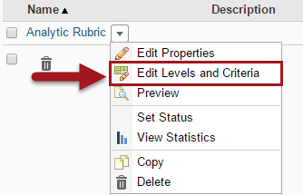

Once on the Levels and Criteria page you have the ability to customize the settings for each of your criterion.

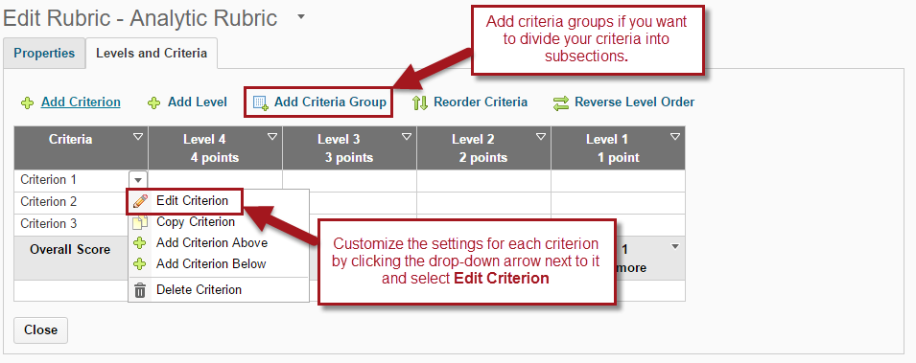
Below is the edit criterion page, the steps used to customize each criterion will be repeated for each section.

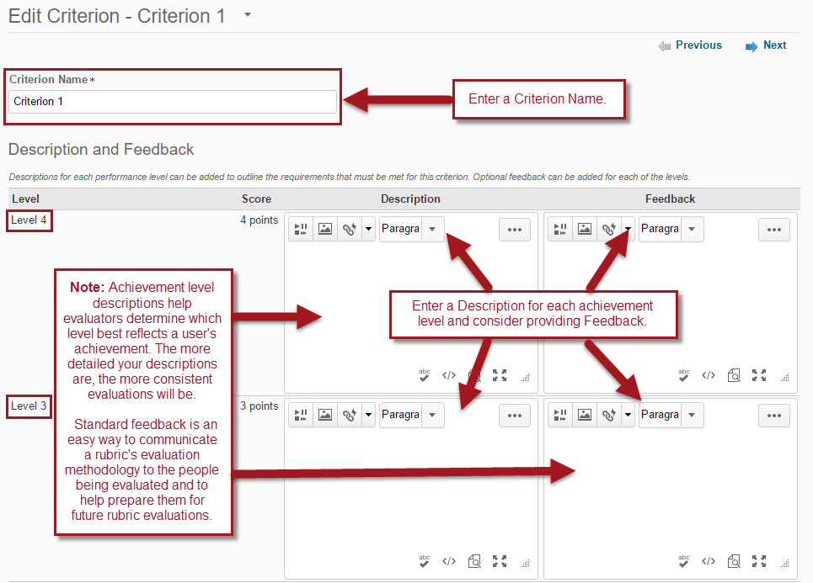

After you have customized the criterion you may now move on to editing the levels of your analytic rubric.

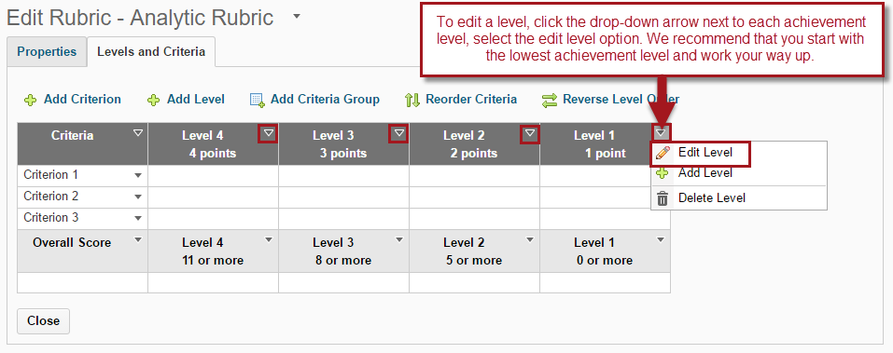

Below is the edit level page, the steps used to customize each level will be repeated for each section.

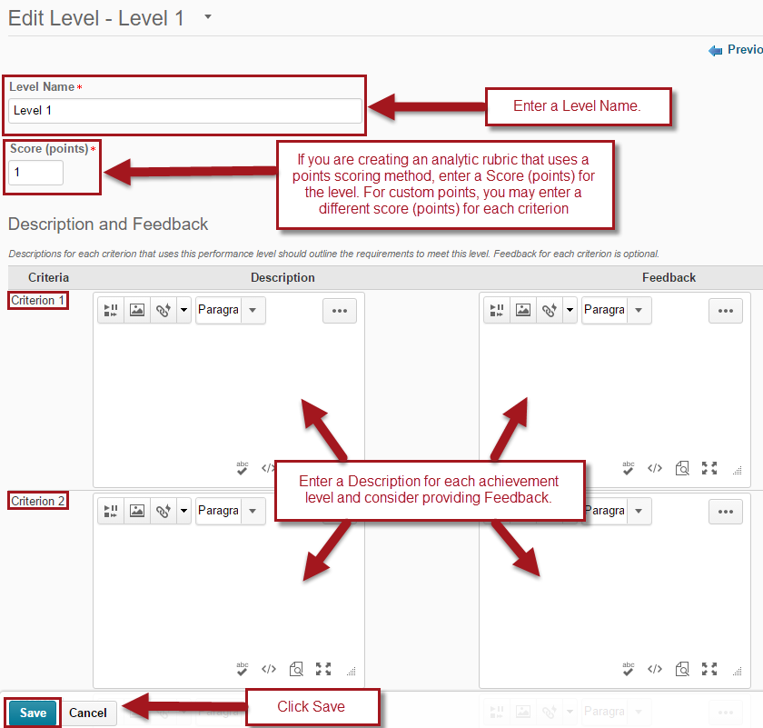

Initial Setup (Holistic Rubric)
- Locate the “Resources” section of Desire2Learn which can be found on your course homepage NavBar then choose the “Rubrics” option.
-or-
Click the “Create Rubric in New Window” during the properties set up of an activity such as a Quiz, Dropbox Folder, or a Discussion. (Below is an example of the properties page of a dropbox folder where a Rubric can be created)
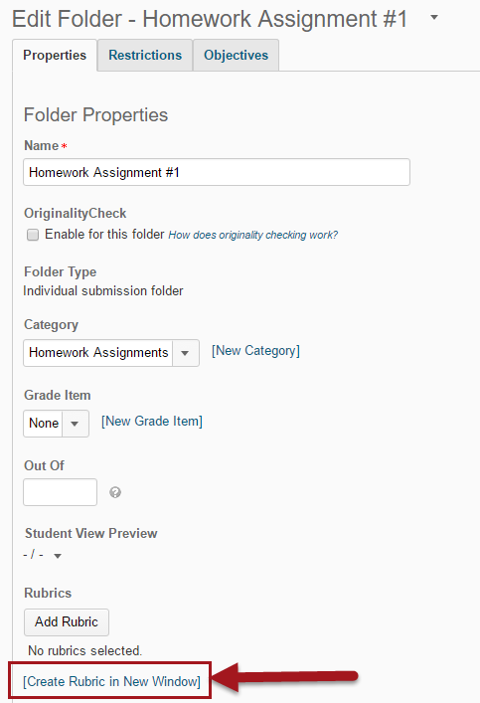
- Click the “New Rubric” button.

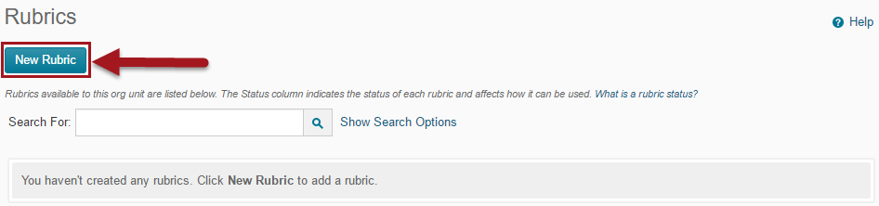

- Rubrics Properties Page.

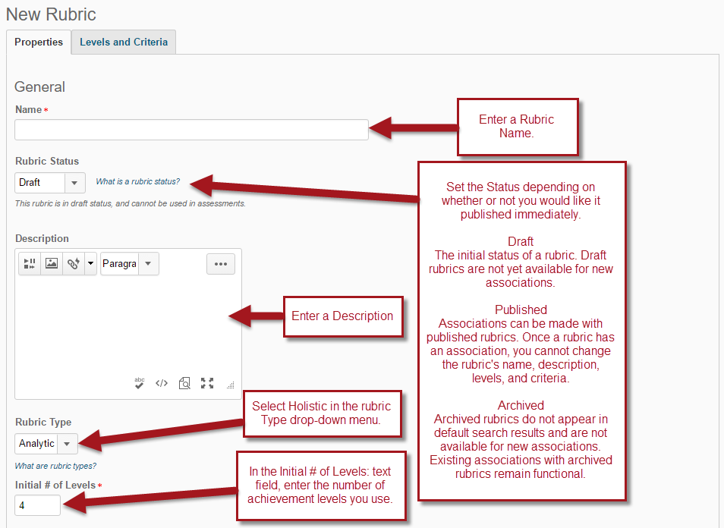

Rubrics Properties Page continued.

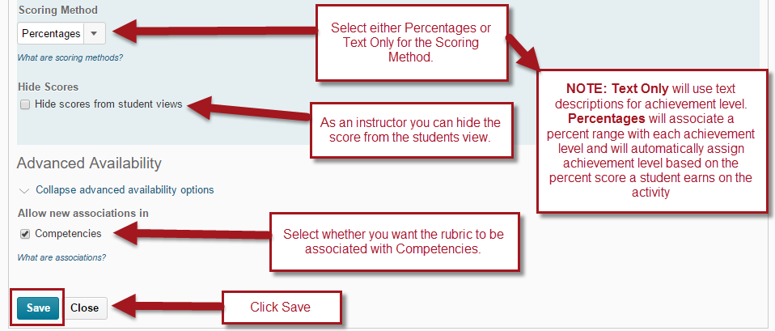

- Defining the achievement levels:
Click the Levels tab on the New Rubric Properties Page or go to the Edit Rubric page to edit the levels of your rubric. 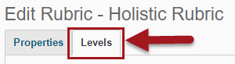

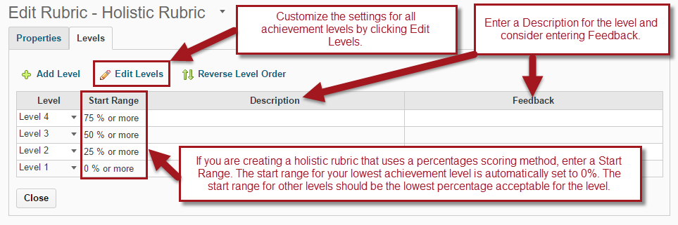
NOTE: Achievement level descriptions help evaluators determine which level best reflects a user's achievement. The more detailed your descriptions are, the more consistent evaluations will be. Standard feedback is an easy way to communicate a rubric's evaluation methodology to the people being evaluated and to help prepare them for future rubric evaluations.

